**Squints and Lazy Eyes**

Here is some basic information

to help you and to help your child

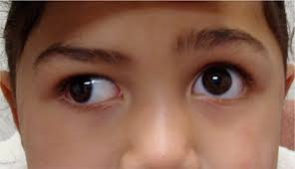

**What is a Squint (strabismus) and a Lazy Eye (amblyopia)?**

A squint can occur on its own, where one eye is turned but both have good vision. The child may be seen to “swap” so sometimes one eye will be straight and then the other.

Lazy eye is when one or both eyes have poor sight even with glasses or contact lenses

Squint and amblyopia can occur together, where the turned eye also has poor vision; this is the most common.

A turned eye causes no discomfort or double vision as the brain does not pay attention to it; this is called suppression.

**Vision Therapy** or eye training will be specially programmed to improve visual efficiency, eye movement skills including visual tracking, focusing, stereo-vision, awareness of space, visual perceptual skills, and co-ordinated movement of the whole body.

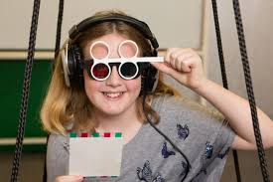

**Surgery** in general is used to let the patient appear to have “straight” eyes; sometimes after surgery spectacles may still be required and the eyes may not be perfectly straight. Vision Therapy may also be needed to “teach the eyes to work together”.

**Mrs Eileen Gay BSc Hons FCOptom and accredited BABO optometrist**

**Check out our website for more information**

**www.eileengayopticians.co.uk**

**There are three ways of treating squints and lazy eyes:**

These are 1) Spectacles or contact lenses

2) Eye exercises and/or patching

3) Surgery

These days, **spectacles** can be fun – many children enjoy theirs especially if they are sports or “designer labels”.

**Contact lenses** are safe for children as long as the child is sensible and is able to handle them themselves. If there is a big difference in prescription between the two eyes then contact lenses will usually be recommended rather than glasses as they give more “natural” vision and the eyes will work better together.

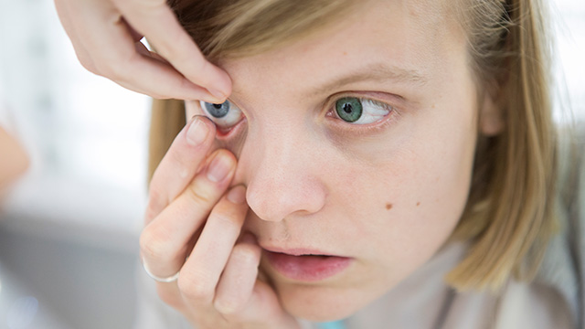

**What causes a Squint or Amblyopia?**

A turn in the eye may be triggered by illness, fatigue, or close work when the eyes cannot cope with it. It can also be inherited.

Most squints develop gradually- any that develop overnight need urgent attention from an Optometrist or Ophthalmologist.

Unfortunately, children very rarely “grow out” of a squint, and it may get worse if untreated.

The brain is very adaptable and can change so that vision (eye-sight) is almost as good as “normal”. However, the child will not be able to see so well in depth and may be more clumsy than others in their class. It may also affect their progress at school

There are various options for treating these conditions and no single approach is better than any of the others – indeed two or even all three treatments may be the best way forward.

