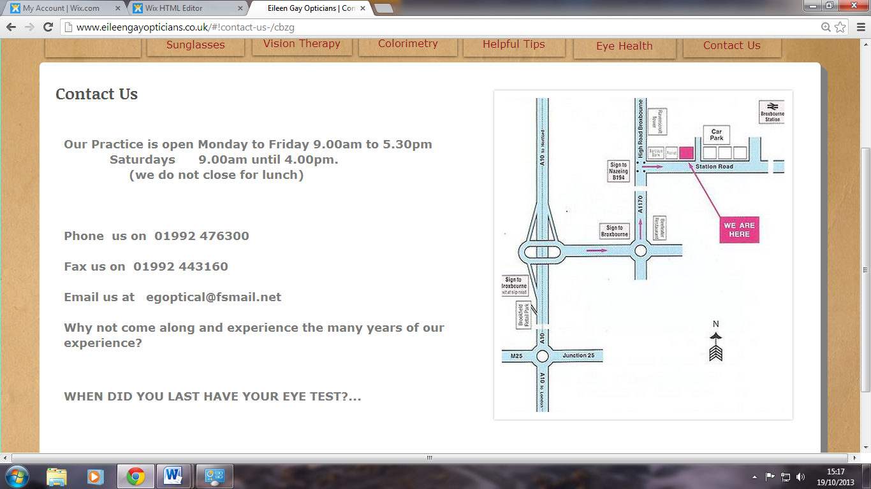

EILEEN GAY OPTICIANS

8 STATION ROAD, BROXBOURNE

HERTFORDSHIRE EN10 7QU

TELEPHONE: 01992 476300

FACSIMILE: 01992 443160

EMAIL: [eileengay@fsmail.net](mailto:eileengay@fsmail.net)

www.eileengayopticians.co.uk

Signs of Vision Problems:

-Blurring of words when reading

-Close working distance when writing

-Blinking or rubbing eyes a lot

-Getting rapidly tired at school and often exhausted at the end of the day

-Headaches or aching eyes

-Difficulties copying from the board or book, often slowly

-Poor co-ordination or history of co-ordination

-Loss of concentration or poor concentration span

-Loss of place while reading

-Missing out or replacing letters, words or numbers

-Using a finger to keep place after initial period of learning to read

-Able to learn spellings but not remember them in creative writing

-Poor visual memory

-Covering one eye when reading

-Homework taking longer than it should

-Poor at ball skills and team games

-Not understanding what has been read



WHAT IS VISION THERAPY?

EILEEN GAY B.Sc., Hons. FC Optom.

Registered B.A.B.O. Optometrist

Associate Member O.E.P.



This can result in lack of concentration, headaches, blurred words when reading and tiredness, all of which are very limiting especially in the years of schooling.

To better understand the concepts of visual “hardware” and “software” let us consider a normal, young, healthy six year old child learning to ride a bicycle. When the child first tries to ride a bike they are likely to fall off a few times. This is not because the child’s “hardware” is faulty, e.g. their arm and leg muscles not working; it is simply a case of inexperience, or lack of software use. With practice the child will become more confident as he or she builds new skills or “software”.

The same principle can be applied to the whole visual system.

If a child is having problems at school, seeing the board or reading for example, it doesn’t necessarily mean that they’re deficient, it could just be that they haven’t learnt to co-ordinate them properly.

In practice no one has developed the ultimate visual system, but many people have developed visual skills far outside the normal range. The difference between elite athletes and ones who don’t quite make the grade is sometimes the difference in their visual abilities.

Their excellent visual efficiency means they can react quicker to their surroundings, putting them in a league above their fellow competitors.

Signs of Vision Problems:

-Blurring of words when reading

-Close working distance when writing

-Blinking or rubbing eyes a lot

-Getting rapidly tired at school and often exhausted at the end of the day

-Headaches or aching eyes

-Difficulties copying from the board or book, often slowly

-Poor co-ordination or history of co-ordination

-Loss of concentration or poor concentration span

-Loss of place while reading

-Missing out or replacing letters, words or numbers

-Using a finger to keep place after initial period of learning to read

-Able to learn spellings but not remember them in creative writing

-Poor visual memory

-Covering one eye when reading

-Homework taking longer than it should

-Poor at ball skills and team games

-Not understanding what has been read

Vision Therapy

Vision therapy is a course of exercises and visual activities designed to develop those abilities that are either not present or not built upon those that have been under developed; put another way, to build upon the visual “software” mentioned earlier.

Glasses may also be prescribed in conjunction with vision therapy, in order to train the eyes and make them work in a more efficient way.

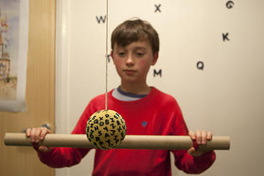

Types of problems which Vision therapy may counter:

* Dyslexia
* Dyspraxia
* Learning problems in the classroom
* Eye strain in the office, including eye strain associated with computer use
* Sports performance
* Eye turns (squints) and lazy eyes
* Headaches, double vision and fatigue
* Poor co-ordination and clumsiness

This can result in lack of concentration, headaches, blurred words when reading and tiredness, all of which are very limiting especially in the years of schooling.

To better understand the concepts of visual “hardware” and “software” let us consider a normal, young, healthy six year old child learning to ride a bicycle. When the child first tries to ride a bike they are likely to fall off a few times. This is not because the child’s “hardware” is faulty, e.g. their arm and leg muscles not working; it is simply a case of inexperience, or lack of software use. With practice the child will become more confident as he or she builds new skills or “software”.

The same principle can be applied to the whole visual system.

If a child is having problems at school, seeing the board or reading for example, it doesn’t necessarily mean that they’re deficient, it could just be that they haven’t learnt to co-ordinate them properly.

In practice no one has developed the ultimate visual system, but many people have developed visual skills far outside the normal range. The difference between elite athletes and ones who don’t quite make the grade is sometimes the difference in their visual abilities.

Their excellent visual efficiency means they can react quicker to their surroundings, putting them in a league above their fellow competitors.

What is Vision?

Vision is much more than just seeing clearly. It is the ability to identify, interpret and understand what is seen and to do so efficiently.

It is vision that allows a driver of a car to judge the speeds of surrounding vehicles, and alerts them to pedestrians or potential hazards.

Vision enables a footballer to direct and swing his leg at exactly the right time to connect with the ball.

It is vision that allows us all to understand what we are reading.

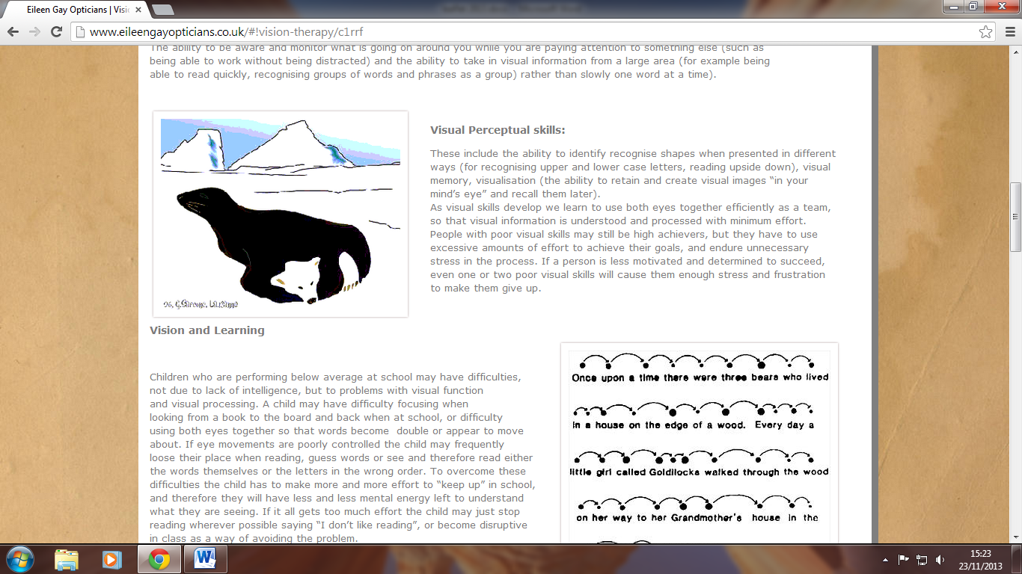

Nearly everybody is born with the necessary “hardware” for good vision. Vision is a learnt process that is developed from birth, with skills and experiences building step by step to form an efficient visual, “software” system.

However, sometimes some of these steps are not completed or missed altogether, resulting in an inadequate level of vision.